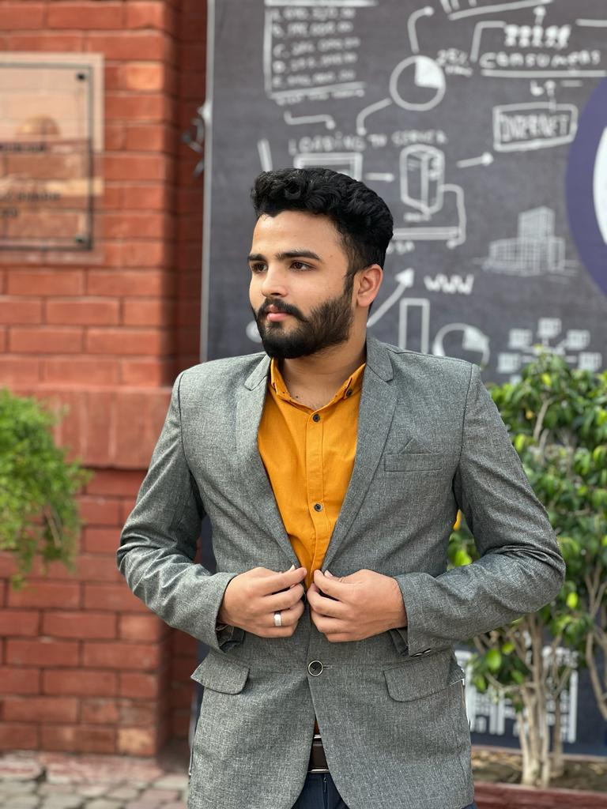

Hey, there I’m a front-end Web Developer with HTML, CSS, Bootstrap, and JavaScript. in addition to I’m expert in C++ and python logic building with Object oriented programming OOP and Data Structures & Algorithms.

Currently I’m working at CodSoft as Web Development Intern. Expecting great experience from this company.

Learning Full Stack Web Development for better command in Development Industry.

**Profile**

**Education**

**MUSTEHSAN FAROOQ**

**Accounts Links**

* Matric (computer science)

(City District Govt Boys High School Lahore Pakistan)

* FSC (Pre engineering)

(Government M.A.O college Lahore Pakistan)

* Bachelor of Computer Science (BSCS) (Present)

(University of Central Punjab Lahore Pakistan)

**Projects**

* **Web Development**
* Amazon Clone (Landing page)
* Portfolio website
* Arithmetic Calculator (HTML, CSS, and JavaScript)
* **C++**
* Library Management System
* Matrix Manipulator
* Guess the number (game)
* **Python**
* Data Normalization
* **SQL Database**
* Hotel Management System

ot

* **[LinkedIn](https://www.linkedin.com/in/mustehsan-farooq-850462237)**
* [**GitHub**](https://github.com/Mustehsan-Codes)
* [**Facebook**](https://www.facebook.com/mustehsan.farooq786?mibextid=ZbWKwL)

Shad Bagh Lahore Pakistan

mustehsanfarooq0@gmail.com

03174645310







**Hobbies**

* Coding
* Poetry
* Singing
* Cricket

**Contact**

* **Front-End Web Development**
* HTML
* CSS
* Bootstrap
* JavaScript
* **C++**
* Object Oriented Programming (OOP)
* Data Structures and Algorithms (DSA)
* **Python**
* numPy
* Pandas
* NLTK
* MatPlot
* **SQL Database**
* **Assembly Language**

**Skills**